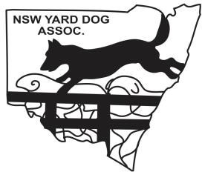
NEW SOUTH WALES YARD DOG ASSOCIATION
Incorporated in NSW under the Association Incorporation Act, 1984
Post 756 West Plains Rd, Corinella NSW 2871
Email yarddogsnsw@gmail.com Web www.yarddogsnsw.com

PRESIDENT  Mr Nathan Cayfe Phone 0404 045 500 | SECRETARY  Miss Felicity Nolan Phone 0400 951 717 | TREASURER  Mr Oliver Hanson Phone 0430 112 600

Point Score Officer Megan Rutherford
Address: “Dinta” 230 Fitzgerald’s Valley Road, Fitzgerald’s Valley NSW 2795
Email: mkirby_309@hotmail.com
Mobile: 0417 004 051

All results are to be sent directly to the Point Score Officer. This can be done either via email, post or phone using the details above.

This is an example only:
Encourage judged by Nick Foster
1 | Glen Noakes | Abbie | 182
2 | Paul Adams | Bart | 173
3 | Paul Adams | Tom | 86

Name of trial…………………………………………………………………………………..
Location………………………………………………………………………………………..
Date…………………………………………………………………………………………….
Results submitted by………………………………………………………………………….

